Student Name : Priyanka Chandwani UID: 25MCI10122
Branch : MCA (AI & ML) Section/Group : 25MAM-1-A Semester : 2nd Date of Performance: 24.02.2026
Subject Name : Technical Training Subject Code : 25CAP-652

Experiment 5:
Experiment Aim: To gain hands-on experience in creating and using cursors for row-by-row processing in a database, enabling sequential access and manipulation of query results for complex business logic. (Company Tags: Infosys, Wipro, TCS, Capgemini)

Tools used: PostgreSQL

Objectives
- Sequential Data Access: To understand how to fetch rows one by one from a result set using cursor mechanisms.
- Row-Level Manipulation: To perform specific operations or calculations on individual records that require conditional procedural logic.
- Resource Management: To learn the lifecycle of a cursor: Declaring, Opening, Fetching, and importantly, Closing and Deallocating to manage system memory.
- Exception Handling: To handle cursor-related errors and performance considerations during large-scale data iteration.

Experiment Steps:

Table Creation and Data Storing-

CREATE TABLE Employee (
EmpID INT PRIMARY KEY,
EmpName VARCHAR(50),
Experience INT,
PerformanceRating INT,
Salary DECIMAL(10,2)
);

INSERT INTO Employee VALUES
(1,'Amit',3,4,30000),
(2,'Neha',6,5,55000),
(3,'Rahul',1,3,20000),
(4,'Pooja',8,5,70000);

select * from employee;

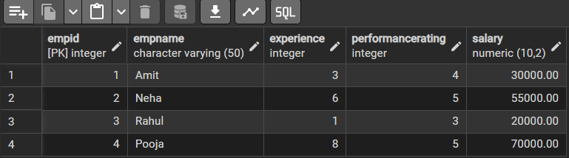

Step 1: Implementing a Simple Forward-Only Cursor
Creating a cursor to loop through an Employee table and print individual records.
DO $$
DECLARE
emp_cursor CURSOR FOR SELECT * FROM Employee;
emp_row RECORD;
BEGIN
OPEN emp_cursor;
LOOP
FETCH emp_cursor INTO emp_row;
EXIT WHEN NOT FOUND;
RAISE NOTICE '% % %', emp_row.EmpID, emp_row.EmpName, emp_row.Salary;
END LOOP;
CLOSE emp_cursor;
END $$;
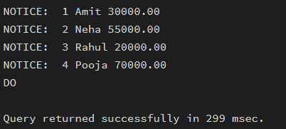

Step 2: Complex Row-by-Row Manipulation
Using a cursor to update salaries based on a dynamic "Experience-to-Performance" ratio logic.
DO $$
DECLARE
emp_cursor CURSOR FOR SELECT * FROM Employee;
emp_row RECORD;
increment INT;
BEGIN
OPEN emp_cursor;
LOOP
FETCH emp_cursor INTO emp_row;
EXIT WHEN NOT FOUND;
increment := emp_row.Experience * emp_row.PerformanceRating * 1000;
UPDATE Employee
SET Salary = Salary + increment
WHERE EmpID = emp_row.EmpID;
END LOOP;
CLOSE emp_cursor;
END $$;
select * from employee;
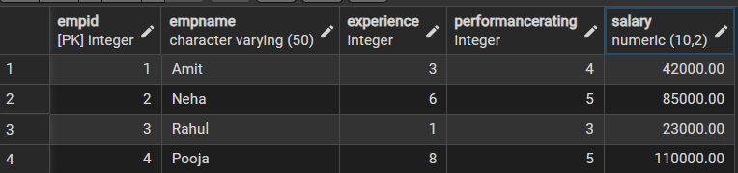

Step 3: Exception and Status Handling
Ensuring the cursor handles empty result sets or termination signals gracefully.
DO $$
DECLARE
emp_cursor CURSOR FOR SELECT * FROM Employee;
emp_row RECORD;
BEGIN
OPEN emp_cursor;

LOOP
FETCH emp_cursor INTO emp_row;
EXIT WHEN NOT FOUND;
RAISE NOTICE '% % %', emp_row.empid, emp_row.empname, emp_row.salary;
END LOOP;
CLOSE emp_cursor;
EXCEPTION
WHEN OTHERS THEN
RAISE NOTICE 'Cursor Error Occurred';
END $$;
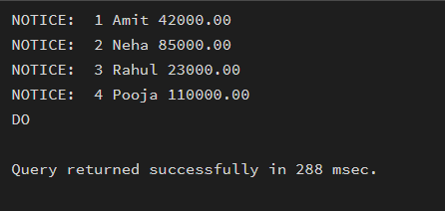

Outcomes:
- Cursor Implementation: Students will be able to design, implement, and manage cursors to solve row-wise processing problems.
- Lifecycle Mastery: Students will demonstrate the correct syntax for declaring, opening, fetching, and closing cursors.
- Error Prevention: Students will understand how to properly handle row-by-row processing exceptions and prevent memory leaks via deallocation.
- Analytical Thinking: Students will be able to apply cursor-based logic to solve real-world scenarios like multi-level payroll adjustments or data migrations.

